Macroeconomics ECO202 Dr. Mary Habib

Notes on Case & Fair Chapter 3

Demand, Supply, and Market Equilibrium

Chapter Overview:

1. Introduction
2. The Circular Flow of Economic Activity and the Major Macroeconomic Markets
3. Analyzing Markets: Demand, Supply, and Equilibrium
4. The Demand Relationship & the Law of Demand
5. The Supply Relationship & the Law of Supply
6. Shifts in Demand & Supply
7. Market Equilibrium Defined and Illustrated
8. Changes in Market Equilibrium

I. Introduction
As we have seen, one of the key words in economics is "allocation." To allocate resources is to determine what to produce using which resources.
Question: How do markets allocate resources?
Answer: Through the mechanics of “supply and demand”.
The allocation of resources through markets is a complex process. The economist approaches this complex process by conceiving a model based on some of the key aspects of the market system. While there are several such models, the "Supply and Demand" model is the best known and most widely used.

II. The Circular Flow of Economic Activity
First a couple of fundamental definitions:

Firm: An organization that transforms resources (inputs) into marketable products (outputs). Firms are the primary producing units in a market economy. (More informally, firms are known as companies).

Households: The consuming units in an economy.

A circular flow diagram shows the interaction of households and firms in the two basic kinds of markets: product (or output) markets and input (or factor) markets.

Product or output markets are the markets in which final or intermediate goods and services are exchanged. Final goods and services are consumer goods and services that are intended for use by households. Intermediate goods and raw materials are goods supplied by firms to other firms for further processing. In the circular flow of economic activity, these two types of products are classified under output or product markets.

Input or factor markets are the markets in which the resources used to produce products are exchanged. Another term for resources is “factors of production”.
They include:
- Labor Markets, in which households supply labor to firms that demand labor.
- Capital Markets, in which households supply their savings (for interest or for claims to future profits) to firms that demand funds to buy capital goods.
- Land Markets, in which households supply land or other real property in exchange for rent, and firms demand this land for production purposes.

In the circular flow chart, these are generically referred to as “input markets”

Terms you should know:

- Capital: Economists define capital goods as goods used (for longer than one year) to produce other goods or services, or to create future value in any other form.

- Investment: Economists define investment as the act of producing or purchasing capital goods (as defined above). To undertake investments firms normally need to raise funds either by borrowing directly from a bank or by selling financial securities in financial markets.

- Bond: This is one way for a company or a government to raise funds in the financial markets. It is a prime example of what is called “debt financing”. A bond is issued by a firm or government in order to borrow money from private citizens (usually through the banking system). The reward to the private citizen or the bank is the interest paid on the bond at regular intervals. Bonds can be of various terms (typically 1, 3, 5, or 10 years). Some government bonds are even for longer terms (ex. 30 years). Bonds can have interest rates that range anywhere from 3% to 10% (typically). The bond market here in Lebanon is confined to the bonds issued by the Lebanese government. In advanced economies such as the U.S. bonds are issued by the government as well as by established firms (IBM, Intel, Microsoft, GM, GE, Ford, etc.).

- Stock: This is another way for a company (but not a government) to raise funds. A stock issued by a firm can be bought by the general public or by organizations (such as retirement funds). A stockholder will own a share of the company according to how many stocks he/she purchases. That’s why another term for stockholder is “shareholder”. Raising funds through stock sales is known as “equity financing”. Stocks provide their holders with returns in the form of “dividends” (a share of the profit agreed upon at the end of each year by the collective body of stockholders). Also, if the stock is resold (in the stock market) when its value has appreciated (increased) then that’s another very important return to the stockholder. Most stock buying throughout the world is done for the purpose of earning a return in this form. Example: You buy a stock of the giant American corporation Intel (the world leader in microprocessor technology and computer chip manufacturing). Intel does well that year earning good profits. Its shares appreciate in the New York stock exchange. You earn a return when you sell the share (or shares) for a higher amount than originally bought.

So now, equipped with the above terminology, we can redefine who “demands” and who “supplies” as follows:

- In output markets, firms always supply.

- In factor markets, households always supply.

The following chart illustrates the concept of circular flow.

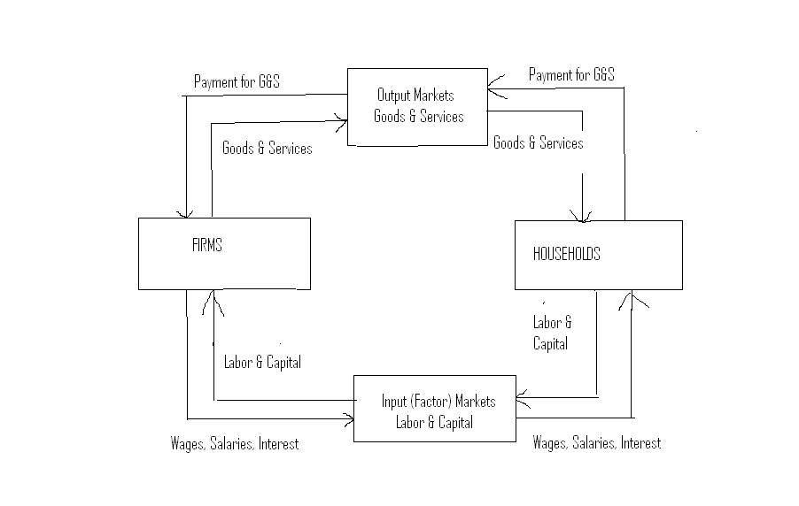

- Goods and services (and capital & labor services from households) flow clockwise. Firms supply goods and services; households supply labor and capital (& land).

- Payments (usually in the form of money) for goods and services and for labor and capital flow counterclockwise. Firms demand labor services from households and pay households for those services. They also demand capital (thru banks) and pay interest for this capital. Households demand consumer goods and services from firms and pay for these goods & services.

III. Analysis of Markets
To "analyze" something is to take it apart into its components.
Thus we must look at:
- Demand
- Supply
- Equilibrium of demand and supply

IV. The Demand Relationship and the Law of Demand
In economics, we need to use terms a little more carefully than they are sometimes used in ordinary discussions.

Definition: Demand
Demand is the relationship between price and quantity demanded for a particular good or service under particular circumstances.

The demand relationship (or curve) tells the quantity the buyers want to buy at each price. The quantity the buyers want to buy at a particular price is called the Quantity Demanded. The quantity demanded is a function of the price.

There are “individual” demand curves, which depict the relationship between price and quantity demanded for individual consumers. However, in economics, “demand curve” usually refers to a market demand curve (unless otherwise stated). This is the demand relationship that exists for a particular good or service in the whole market. So we can speak of the demand for computers, or the demand for petroleum, or the demand for Toyata SUVs, and so on, as representing the demand of all the consumers in that particular market (either in one country or in the world).

Note the following two sources of potential confusion:

- Do not confuse between demand and want. We may “want” lots of things and in unlimited quantities, but we “demand” only those things that we have the ability and the willingness to pay for. Example: You may want to own a diamond ring, but if you know you cannot afford to, then you cannot say you have a demand for the ring. However, you may want to own a car. If you are willing to pay its price, then you have a demand for the car.
- Do not confuse between demand (which is a relationship or a schedule of price-quantity combinations) and the quantity demanded (which is specific for each price level). The word "demand" refers to the willingness and ability of people to purchase the good or service in the market at different price levels. The demand relationship expresses that willingness and ability for the whole range of prices. On the other hand, the quantity that people buy at each price is called the "quantity demanded" at that price.
By convention, in economics, we put the price on the vertical axis, and the quantity demanded on the horizontal axis.
Here is a typical "demand curve" based on some arbitrary numbers. Assume the numbers reflect cellular telephone calls, with the price (y-axis) being price per call and the quantity (x-axis) being number of calls demanded.
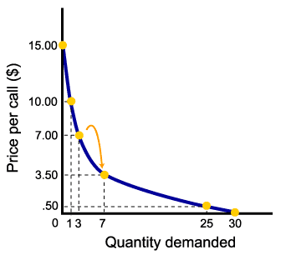
Remember: when we speak of "demand" we usually mean the entire demand relationship, that is, the entire demand curve or table. By contrast, the "quantity demanded" is the particular point on the demand curve.

Notice that the demand curve is typically downward sloping.
Economists call this the Law of Demand:
The law of demand simply states that as the price of a good increases the quantity demanded will be less, ceteris paribus.
Ceteris paribus
"Ceteris paribus" is a Latin phrase often used by economists, literally meaning "other things equal." Used in the context of an economic model, it means all the variables that might affect the equilibrium in the model are held constant. Only the ones we say are changing are allowed to change.

In the example of the demand curve, we say that the law of demand applies "ceteris paribus," meaning that other things that might influence quantity demanded, such as the consumers' income and the population, are treated as being constant. If those things change, that would shift the demand curve.

Also note that the demand curve intersects the X axis. This is to indicate that even at a zero price, there would be a limited demand quantity (as this is constrained by human or social capacity). Furthermore, the demand curve intersects the Y axis. This shows that at a high enough price, the quantity demanded will eventually drop to zero.

V. The Supply Relation & the Law of Supply
Just like in the demand case, there are several primary facts to note here that roughly correspond to the ones above. We can summarize them as follows:

- Supply decisions depend on profit potential.
- Profit is the difference between revenues and costs.
- Quantity supplied represents the number of units of a product that a firm would be willing and able to offer for sale at a particular price.
- A supply schedule is a table showing how much of a product firms will supply at different prices.
- A supply curve is a graph illustrating how much of a product firms will supply at different prices.
- The law of supply states that there is a positive relationship between price and quantity of a good supplied.
- This means that supply curves typically have a positive slope.

Just like with the demand concept, when we use the term "supply" we usually mean the entire supply curve or relationship, while if we refer to the quantity people want to sell at a particular price, we say the "quantity supplied."
Like a demand curve, a supply curve can refer to the supply schedule of one individual firm. More commonly, the term “supply curve” usually means the market supply curve (i.e. all the firms engaged in the production of this particular good or service either domestically or internationally).

VI. Shifts in Demand & Supply
A) Shifts in Demand:

Here is a figure to illustrate an increase in demand. The demand curve shifts from D₁ to D₂. With the new demand curve, there is a greater quantity demanded at every price. This is what is meant by an increase in demand.

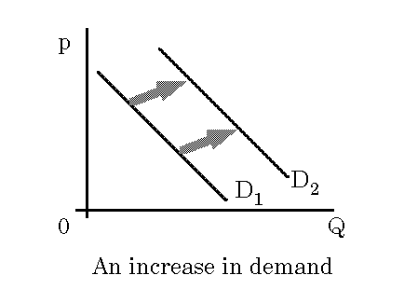
It’s very important to note the following:
A change in demand is not the same as a change in quantity demanded.
- A higher price causes lower quantity demanded. Similarly, a lower price causes higher quantity demanded. Both of these represent movements along the demand curve.
- On the other hand, changes in the determinants of demand (other than price) cause a change in demand, or a shift of the entire demand curve (like from D₁ to D₂ in the example above).

What are the major “non-price” determinants of demand that cause the whole demand curve to shift?

Here are the main determinants of demand:

1. A change in income for the average consumer.
- If an increase in income causes an increase in the demand for a particular good, that good is called a "normal" good.
- If an increase in income causes a decrease in the demand for a particular good, that good is called an "inferior" good.
2. A change in the population (increases or decreases).
3. Changes in the prices of other goods.
- Complements: These are products we use in conjunction (together), such as tea and sugar, computer hardware and software, camera and film, cars and gasoline. If the price of a complement increases, the demand for this complement decreases. If the demand of a complement increases, it is natural that the demand for the good that is used along with it would also increase.
- Substitutes: If the price of a substitute increases, then the demand for that substitute decreases. Therefore, the demand for the alternative good would move in the opposite direction (i.e. increase) (examples include coffee vs. tea, IBM vs Apple computers, Japanese cars vs. American cars, traveling by bus vs. traveling by train, etc.)
The above three determinants are economic factors. There are a couple of other non-economic factors:
4. Changes in consumer tastes and preferences: The demand for almost everything changes over time. Some demands even disappear all together while others are created. This is because societies and cultural norms change. Primary examples include the demand for sportswear, the demand for cellular phones, the demand for computers, the demand for certain types of cars, the demand for health foods, etc. Not only have demands been created for modern technology gadgets such as computers and cell phones, but demands have also been created for new kinds of services (e.g. childcare services, which have emerged with the increasing involvement of women in labor markets).
5. Changes in Information: Any time new information becomes available due to scientific or technological discoveries, consumer behavior is likely to change. An example would be the increased demand for orange juice that occurred when it was revealed that Vitamin C was an important antioxidant. Note that in many instances demand for certain things decrease as societies advance. A prime example of that is the demand for smoking (cigarettes), which has been decreasing dramatically in industrial countries with emerging information related to the health risks of cigarette smoking.
6. Changes in Expectations: This is often the most important determining variable of many price fluctuations that we observe in the real world. As an example, consider the following puzzles: Why does the world price of oil or gold change so much, sometimes from day to day? Why does the exchange rate of the dollar vis a vis the Euro (i.e. the “price” of the dollar in terms of Euro) changes from day to day? Often, these changes occur even when there is no underlying “current” supply or demand factor that is causing these changes. The answer turns out to be “expectations”. While the above listed factors reflect “current” events, expectations reflect “future expected” events. If people expect a war to occur in the Middle East (future event), they might change their demand for oil today (current effect). If people expect the US economy to begin to improve soon, they might demand more dollar-based assets now so that may change the Euro price of the dollar now. Numerous other examples exist that confirm the importance of expectations

B) Shifts in Supply:
Here is a figure to illustrate an increase in supply. The supply curve shifts to the right, from S₁ to S₂, so that the new supply curve shows a greater quantity supplied at every price. That is what we mean by an increase in supply.

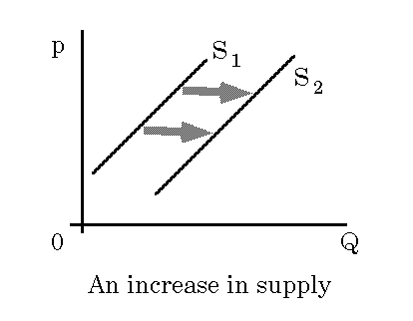

The figure below, on the other hand, illustrates a decrease in supply. The supply curve shifts to the left, from S₁ to S₂. The new supply curve shows a smaller quantity supplied at every price, and that is what we mean by a decrease in supply.
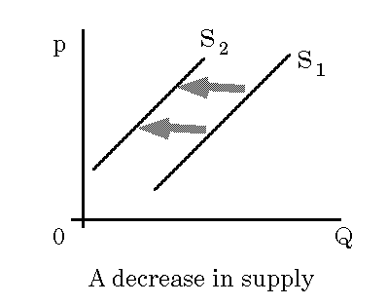

Again, just like with demand, price is the factor that causes movements along the curve. If price increases, quantity supplied increases and visa versa.

What determines supply? Here’s a list of the main determinants. Those are the factors that would cause the whole supply curve to shift:

1. Changes in the cost of production. This often comes from changes in the prices of inputs required for the production of this good.
- Labor, which constitutes the highest cost item for most firms
- Raw materials (or intermediate goods)
- Cost of energy (fuel, electricity, etc.), which is another major input into the production process
In general, whenever the cost of inputs increase (hence the cost of production), the supply curve of the good in questions shifts to the left (in). This means that there will be less supplied of the good at every possible price. [Recall that a higher cost of production means a lower profit, which leads to less being produced at every market price.]
2. Changes in technology. An improvement in production technology causes the supply curve to shift right. A good example would be the steady decrease in the price of computer and computer-related products due to the increased efficiency and improved technology of computer hardware production.
As an example, below is a graph that shows what happens when there is an improvement in agricultural technology. In this example, since the factor affecting supply is not the price of soybeans but a technological change in soybean production, there is a shift of the supply curve rather than a movement along the supply curve.
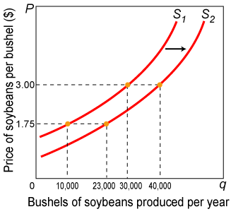
3. Changes in natural conditions (relevant to the production of the good in question).
- Rainfall
- Weather
- Natural disasters

VII. Equilibrium of Supply and Demand

“Equilibrium" exists when the price is at a level where the quantity supplied just equals the quantity demanded. It is the price at which the two curves cross. You can also think of equilibrium as the point at which there is no natural tendency for further adjustment. The corresponding quantity is the quantity that would be traded in a market equilibrium.
What does it mean to say there is no natural tendency for further adjustment? Why do we call this an "equilibrium?"

Let's see what happens when price is not high enough to make quantity supplied equal to quantity demanded:

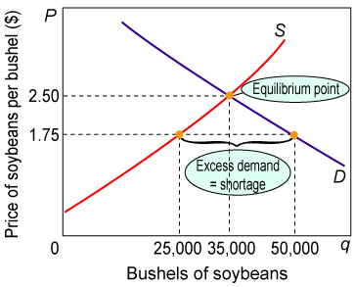

What we see here is that the quantity demanded exceeds the quantity supplied at the price of $1.75. This is a case of “excess demand”. Thus, demanders will compete against one another, offering higher prices for the limited supply, and the price will rise.

What if the price is too high?

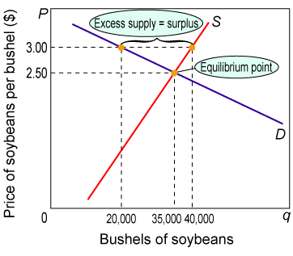

Here we have excess supply -- the quantity supplied exceeds the quantity demanded at the $3.00 price. Thus, suppliers will compete to sell what they can by cutting the price.

VIII. CHANGES IN EQUILIBRIUM
- Higher demand leads to higher equilibrium price and higher equilibrium quantity. This is shown in the diagram below.

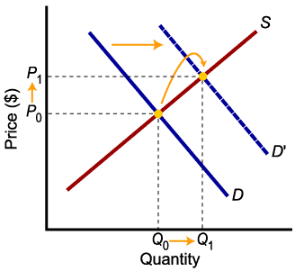

- Higher supply leads to lower equilibrium price and higher equilibrium quantity. This is shown in the diagram below.

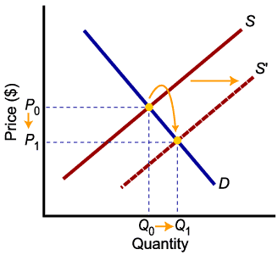

Similarly, in the opposite direction
- Lower demand leads to lower price and lower equilibrium quantity &
- Lower supply leads to higher price and lower equilibrium quantity.
[As an exercise, practice drawing those last two scenarios using similar diagrams like the ones above.]
Relative Magnitude of Change
The relative magnitudes of change in supply and demand determine the outcome of market equilibrium. When supply and demand both increase, quantity will increase, but price may go up or down.
This is illustrated in the two figures below.

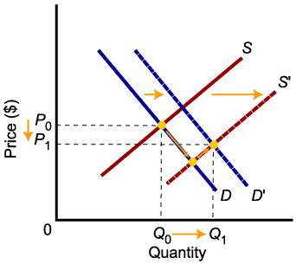
In the above figure, both supply and demand increase, but supply increases more (i.e. supply curve shifts more). As a result, the equilibrium quantity increases but equilibrium price decreases.
In the second illustration (below), demand increases more than supply. The demand curve shifts by a greater magnitude than the supply curve. The result is that both equilibrium quantity and price increase (the new equilibrium lies at the intersection of S’ and D’).

